**Black Eagle Investigation**

Digital Forensics

Maram Alassaf

# Cover page.

Case name: BlackEAgle Kidnapping Case.

Case ID: Case 751515

Date: 11/6/2024

Department/organization: Al-Hussien Technical University.

Investigator name: Maram Al Assaf

Contact information: 21110197@htu.edu.jo

# Table of contents

Contents

Cover page. 1

Table of contents 2

Administration information 3

The executive summary 4

Investigation scope 5

Acquisition and handling of the evidence 5

Investigation environment 6

Tools used in the analysis. 7

Analysis summary 8

Technical Analysis 8

Conclusion 9

Exhibits 10

Revision History 11

# Administration information

It contains:

Case number/case name: Case 751515/BlackEAgle Kidnapping Case.

Department/organization requested the report: Al-Hussien Technical University

**Search Warrant/Authorization for Investigation of Evidence:**

Al-Assaf Organization

CASE NO: 751515

TO: The Honorable Judge Safaa Hriez, Judge of the Amman Court

FROM: Detective Maram Alassaf, Amman Police Department

DATE: June 11, 2024

SUBJECT: Search Warrant/Authorization for Investigation of Evidence Related to BlackEagle Organized Crime Group

1. **AFFIDAVIT**

I, Detective Maram Alassaf, a Detective with the Amman Police Department, submit this affidavit in support of a search warrant.

1. **ITEMS TO BE SEARCHED**

USB Drive: Suspected to contain files, documents, and digital evidence related to BlackEagle’s criminal activities and future plans.

PC Device: Believed to contain emails, documents, browser history, downloaded files, and other data pertinent to BlackEagle’s operations and plans.

1. **BASIS FOR SEARCH**

Probable Cause: The suspect, "Eagle's Eye," is implicated in prior kidnappings by BlackEagle. The seized devices likely hold evidence crucial to preventing future crimes.

1. **REQUEST**

I request a search warrant to conduct a forensic analysis of the USB drive and PC device for evidence related to BlackEagle’s criminal activities and future plans.

1. **AFFIRMATION**

I affirm under penalty of perjury that the information in this affidavit is true to the best of my knowledge and belief.

Signature: Detective Maram

Name: Detective Maram Alassaf

Title: Detective

Law Enforcement Agency: Amman Police Department

Sworn to and subscribed before me on June 11, 2024.

Judge’s Signature: Judge Safaa Hriez

Judge’s Name: Judge Safaa Hriez

Judge of the Amman Court

The participants of the investigation included:

Investigators: Maram Al Assaf

Victims: The daughter of the CEO

Suspects: Eagle’s Eye Organization

Interrogated or reviewed people: No one

# The executive summary

This investigation focused on the series of high-profile kidnappings orchestrated by the organized crime group known as BlackEagle. Following the arrest of a key member of the group, Eagle's Eye, the investigation team examined digital artifacts from the suspect's computer and USB drive. The primary goal was to uncover clues regarding the location and timing of the next planned crime.

Forensic analysis revealed critical data, including hidden files, and recovered deleted information, shedding light on BlackEagle’s operations. Despite this, we did not find direct details about the next planned crime. However, we did uncover valuable leads and evidence of prior kidnappings through communications and financial records, confirming the suspect's involvement.

The integrity of the digital evidence was meticulously maintained, ensuring its reliability in court. Although no immediate threat information was obtained, the findings suggest further areas of investigation and surveillance targets. We recommend continued monitoring of identified leads, enhanced surveillance of BlackEagle associates, and collaboration with cybersecurity experts to improve our digital forensics capabilities for future cases.

# Investigation scope

Summary of the available resources to complete the investigation.

A key member of the criminal organization has been arrested by the Metropolitan Police. This arrest might provide an opportunity to gather information about the next crime of the BlackEAgle group. This member of the criminal’s organization did not confess the location and time of the upcoming crime. So, the investigators decided to search the seized item from the member during the arrest, these items were a USB drive and a PC device.

## Acquisition and handling of the evidence

How the evidence was handled and copied to the workstation:

* Acquisition of Evidence: The evidence which is a USB drive and a PC device were confiscated during the arrest of the criminal. Meanwhile, a proper chain of custody COC document was maintained from the moment that these evidence seized until it reached the work station to ensure the integrity of the evidence so that it can be admissible in court.
* Handling of Evidence: The law enforcement would have followed the standard guidelines of handling process. The evidence wan packaged and sealed to prevent from altering the evidence, also a proper documentation of the time and the person who seized, packaged, and managed the evidence. Also, providing a proper documentation of the duration transport time of the evidence from the scene till the workstation(digital forensic laboratory) to be documented in the chain of custody paper.
* Imaging the Evidence: the moment the evidence is at the workstation they will be imaged, creating a bit-for-bit copy of the original USB drive and PC. This have to be done to protect the integrity of the original devices and to prevent any altering on the original device.
* Analysis: The investigator is a digital forensic expert who will examine these devices using multiple forensic tools looking for any clue that might lead them to the time place of the next crime.

Evidence overview:

* USB drive: Used for storage purposes, the drive may contain files, documents, or other digital evidence that could insights into the operations of the BlackEAgle group, or the location and time of the next crime.
* PC device: The device likely contains critical digital evidence such as emails, documents, browser history, downloaded files, installed applications, and possibly encrypted data. It may provide insights into the activities and plans of the BlackEAgle organization.
* Digital Forensic analyst: The digital forensic investigator will use specialized software and techniques to analyze the forensic images of the PC device and USB drive. The analyst aims to uncover any hidden information, communications, plans, or clues related to the timing and location of the next crime planned by the BlackEAgle group.

## Investigation environment

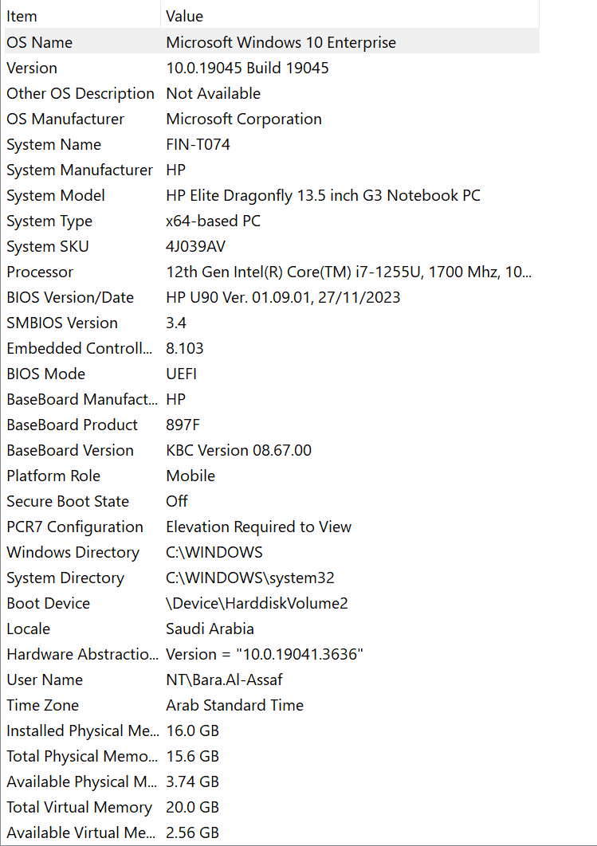 The specs of the PC/laptop and any device used in the investigation.

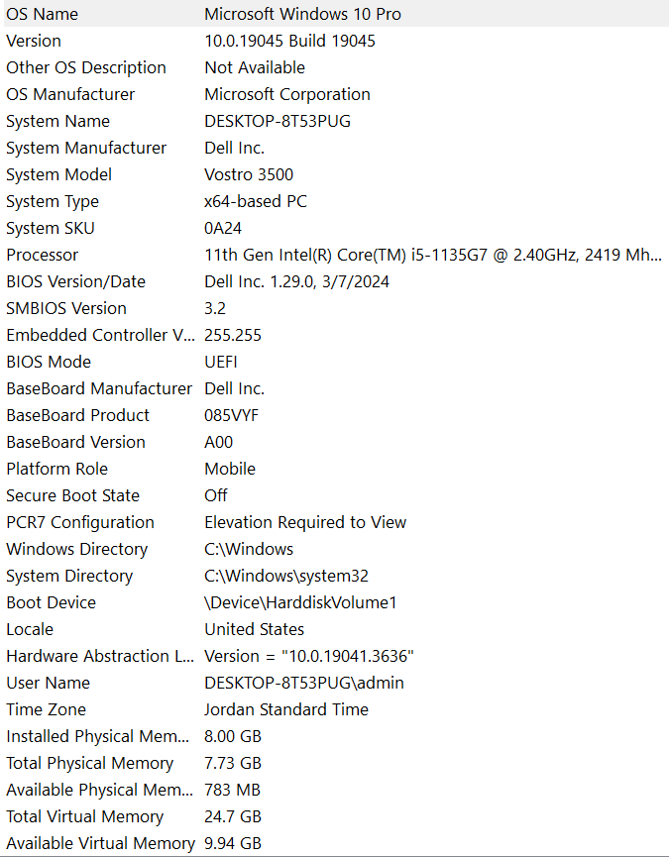

## Tools used in the analysis.

The tools used in the analysis with a description of each one.

|  |  |  |  |
| --- | --- | --- | --- |
| Tool name | Version | Company name | Description |
| 010 Editor | Version 🡪14.0.1.0 | SweetScape Software | 010 Editor is a commercial hex and text editor for Windows, Linux, and macOS. It edits text, binary files, hard drives, processes, and various data formats using Binary Templates. Features include a tabbed interface, search and replace with regular expressions, file comparisons, histograms, checksum/hash algorithms, column mode editing, and support for multiple character encodings. |
| AccessData FTK-Imager | Version 🡪 4.7.1.2 | AccessData Group | AccessData FTK Imager is a forensic tool designed primarily to preview recoverable data from any type of disk. It also has the capability to create exact replicas, known as forensic images, of the data. Additionally, it is available for free. |
| HashMyFiles | Version 🡪 2.4.4.0 | NirSoft | HashMyFiles is a small program that helps you find MD5 and SHA1 hashes for system files. You can easily copy the hashes to the clipboard or save them as text, HTML, or XML files. |
| BrowsingHistoryView | Version🡪 2.5.7.31 | NirSoft | The browser history from many web browsers (Firefox, Chrome, IE, Edge, Opera) is read and shown in a single table by BrowsingHistoryView. It allows history viewing from all user profiles and external drives and includes the following: URL, title, visit time, visit count, browser, and user profile. |
| JumpListExplorer | Version 🡪 2.0.0.0 | Eric R Zimmerman | JumpListExplorer (JLE) records application execution details, broken down by application ID (AppID), by parsing Windows AutomaticDestinations files. It displays files and programs that have been opened by a parent application. Common AppID mappings are kept up to date via Eric Zimmerman's repository. |
| RBCmd | Version🡪 1.6.0.0 | Eric R Zimmerman | An INFO2/$I parser for recycle bin items is what this tool does. File size, original path, and deletion date are among the metadata that are provided by INFO2 files, which also index deleted files. |
| Thumbcache_Viewer | Version🡪1.0.4.0 | Dennis Reneau, Kevin Pagano | With Windows Vista, Windows 7, Windows 8, Windows 8.1, Windows 10, and Windows 11, the thumbcache_*.db and iconcache_*.db database files contain thumbnail images that can be extracted using Thumbcache Viewer. There are two versions of the program: a command-line interface and a graphical user interface. |
| LECmd | Version🡪 1.5.0.0 | Eric R Zimmerman | LECmd is a CLI tool for analyzing lnk data. searching the name or path of the target of the lnk file. |

# Analysis summary

I investigated a USB drive and a PC to uncover the time and location of Black Eagle's next crime. On the USB, I fixed a file system issue to access the data. On the PC, I examined web history, Thumbnail files, deleted files, and linked files, which led me to suspicious downloaded images, and recycled bin files which did not lead me to anything because it was empty. By manually checking these images, I discovered a hidden XML file containing the crucial information. The crime is planned for Tuesday, June 11, 2024, at 12 PM in KHBP.

# Technical Analysis

Analysis for the whole process providing screenshots So now starting with the analysis, I started exploring the USB to look for any evidence regarding the time and location of Black Eagle's next crime. So, as we know data on a physical medium flash drive, is organized, labeled, and governed by a file system, and in the USB when we opened it we found that the byte that is related to the file system type is 07 which means it is using NTFS file system. Now I want to check that the structure of the file is right, starting from the first byte of the file system counting 446 bytes to reach the first partition we will see in the USB there is only one used partition the other 3 partitions are zeros. In the first partition, we want to reach the VBR using the Starting LBA Address that is in the MBR as we can see in the provided screenshot the LBA address is 80 00 00 00 in hexa and in little indian:

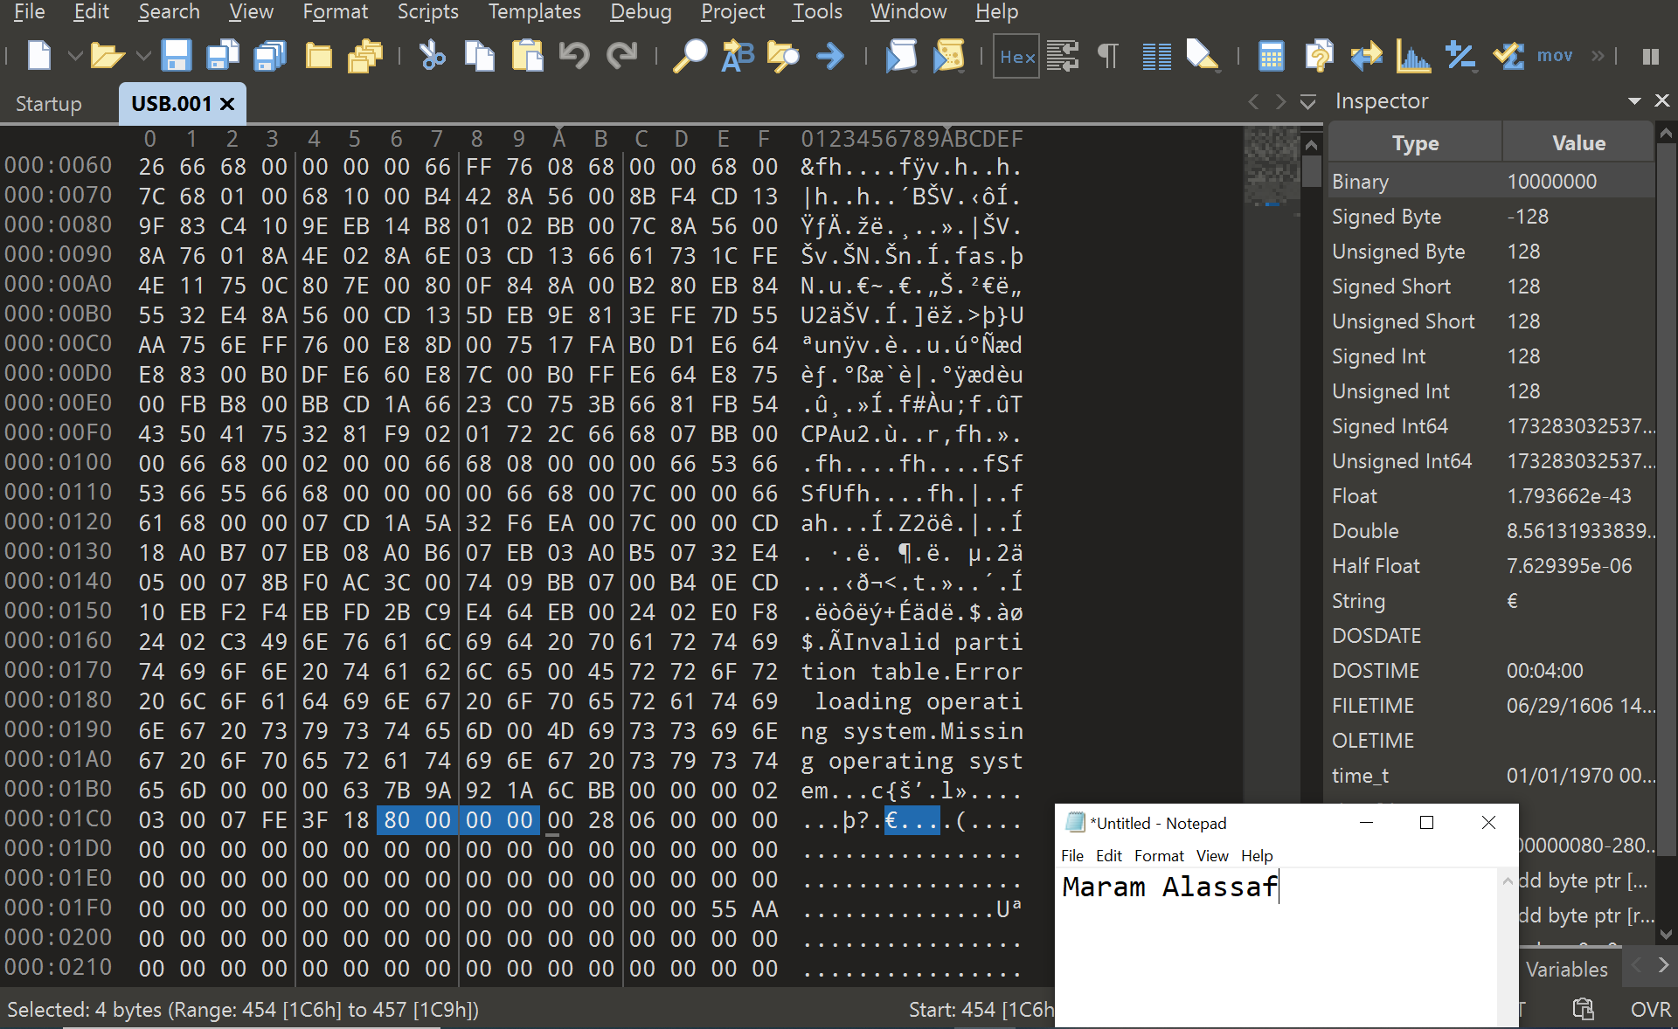

As we learned, we can go to the Volume Boot Record (VBR) using the LBA address in the Master Boot Record (MBR), so when converting the hex value from the little Indian to big Indian we can go to the first sector of the VBR from the first byte of the MBR:

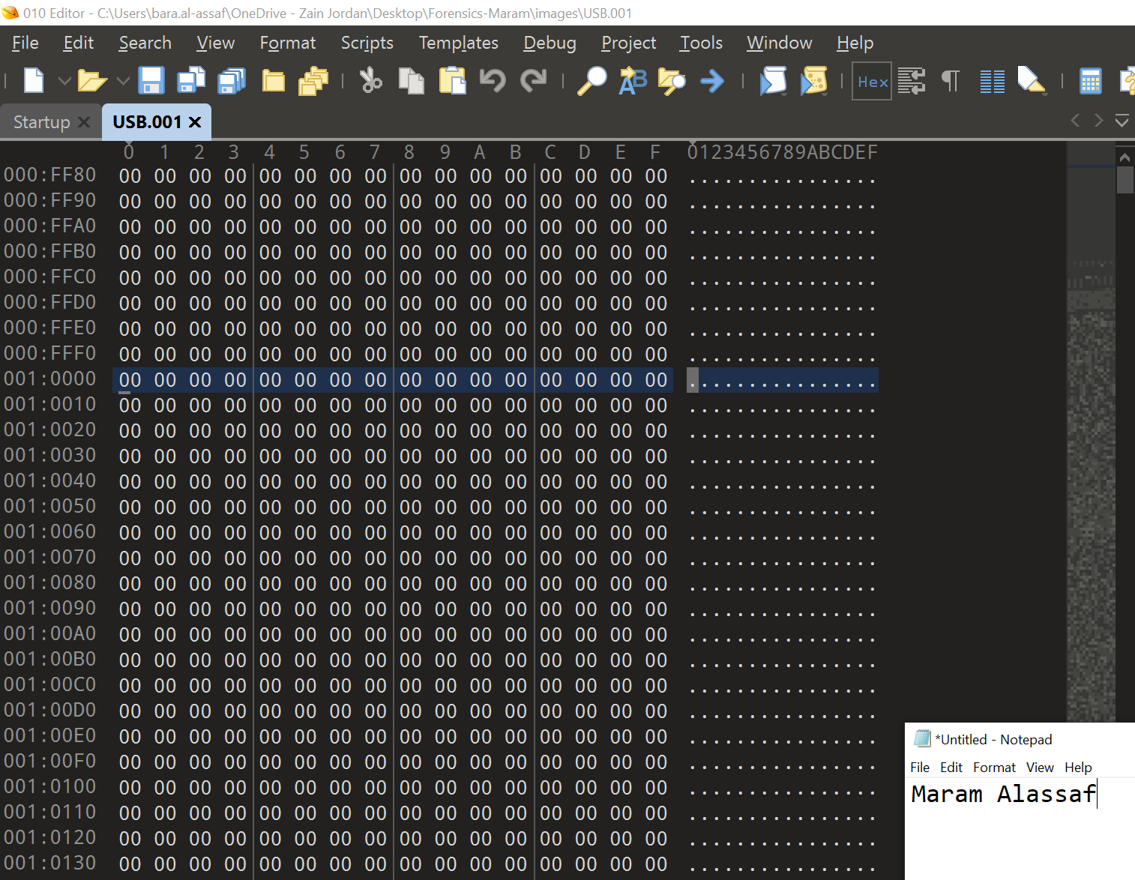So after we went to the first sector of the VBR we found that it was empty (all zeros), look at the screenshot:

So we learned that there is a backup for the VBR file in the last sector of the disk.

How can I find the last sector?

1. From the MBR we convert the size in sectors of the volume to Decimal then we add to it the Starting LBA and then we subtract 1 from the result. Why? Because it is a zero-based indexing the size of the volume will start from 0 to LBA + Size in sectors -1.

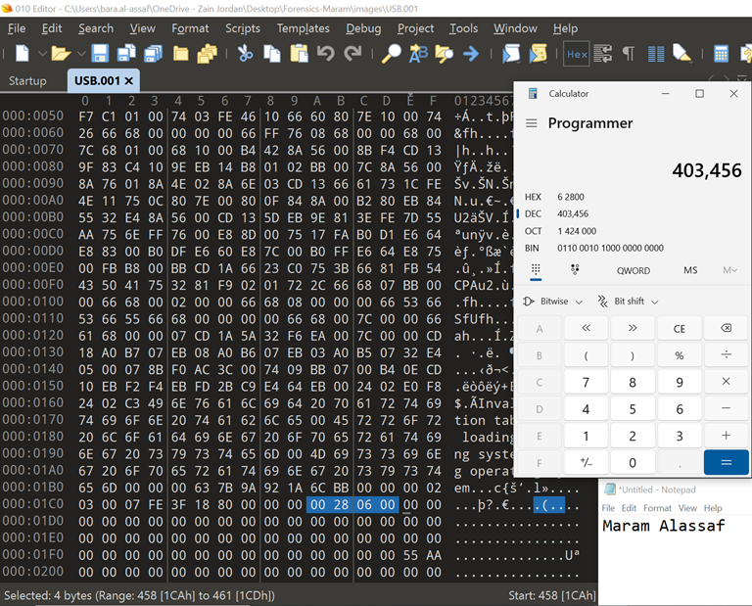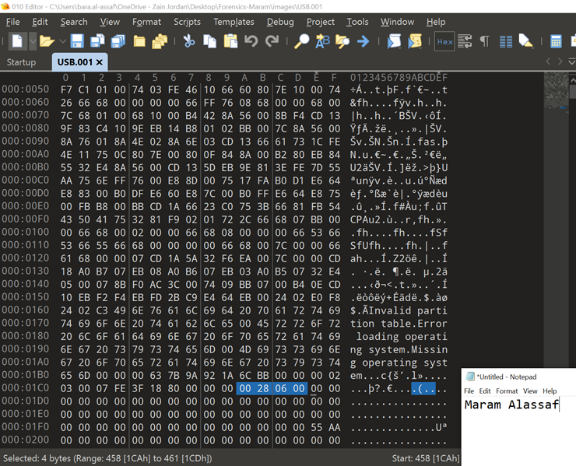

The formula to find the backup for the VBR = Size in sectors (dec) + Starting LBA (dec) -1

= (6 2800)hex → (403,456)dec + (80)hex → (128)dec -1

= (403,583)dec → (6287F)hex.

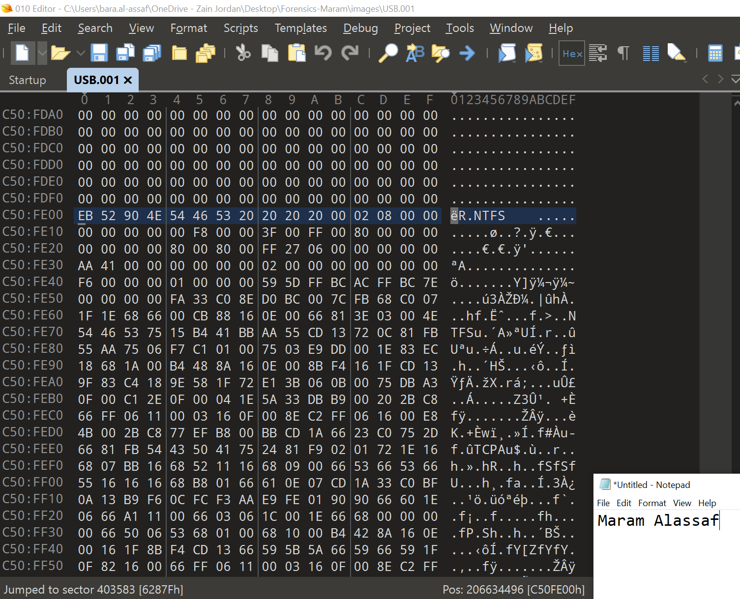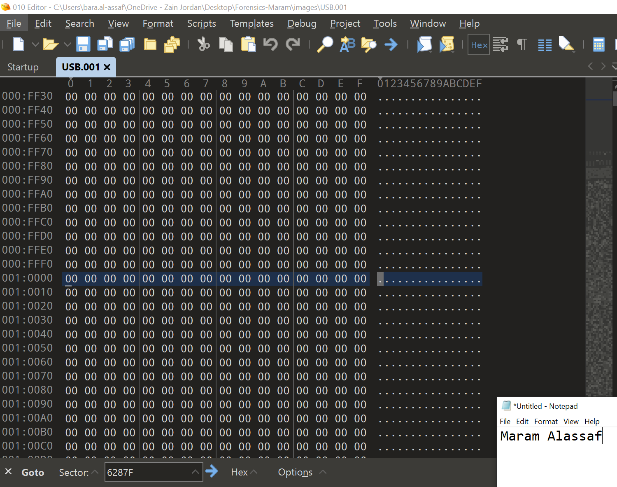So if we go to sector 6287F from the beginning of the empty VBR we will find the backup VBR:

As you can see I found the backup for the VBR and to make sure that this represents the VBR:

1. From the NTFS word at the right.
2. From the jump instruction bytes, the first 3 bytes.

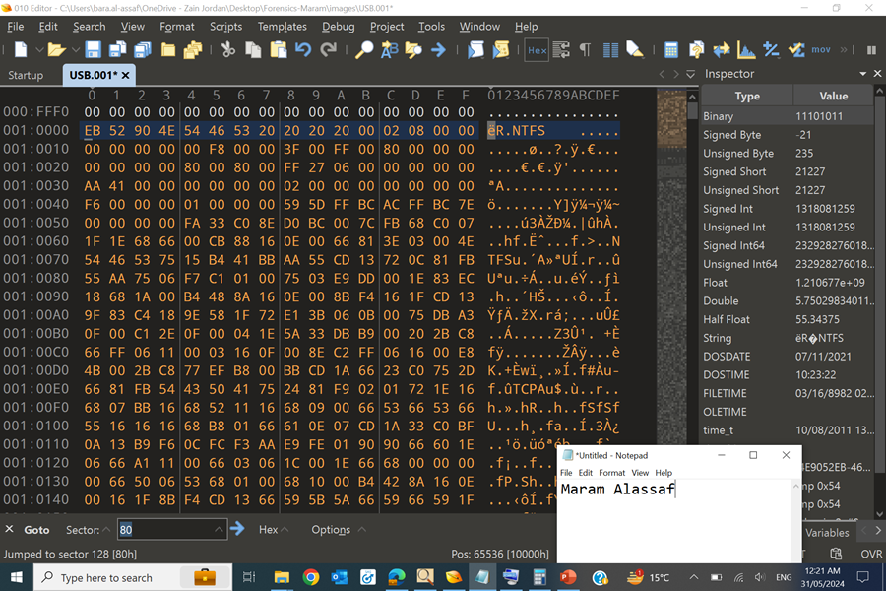Now I am copying the backup and pasting it in its right place.

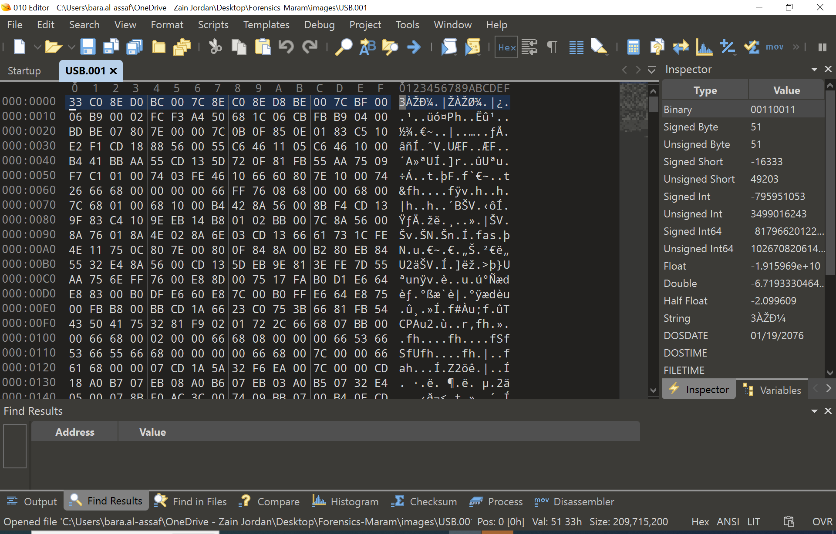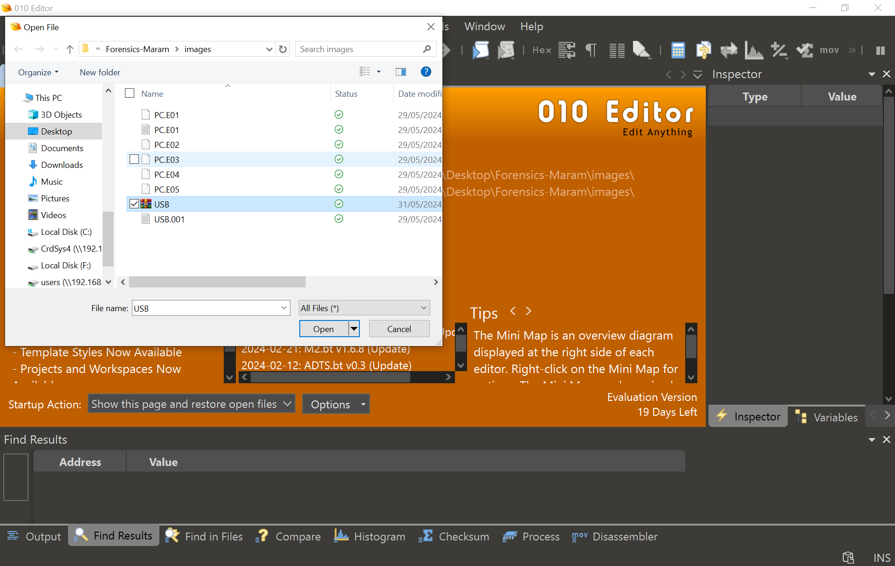The file now should be opened by the 010 editor without any errors, this is done to ensure that my work is correct:

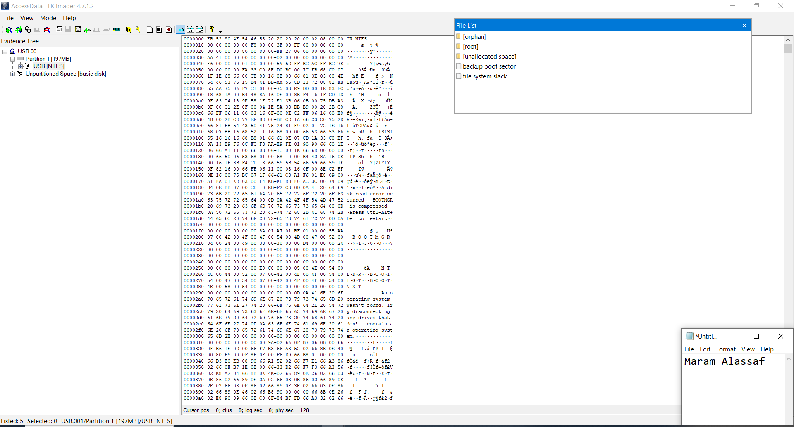Also, the file now should be opened by the FTK imager without any errors and all partitions are now able to be viewed using the FTK imager, this is done to ensure that my work is correct:

Now, Moving on to the second piece of evidence, which is the PC device we will search for any files related to the time and location of the next crime:

I opened the PC device from the FTK imager and started searching the artifacts, starting with:

1. Searching web browser history using (BrowsingHistoryView):

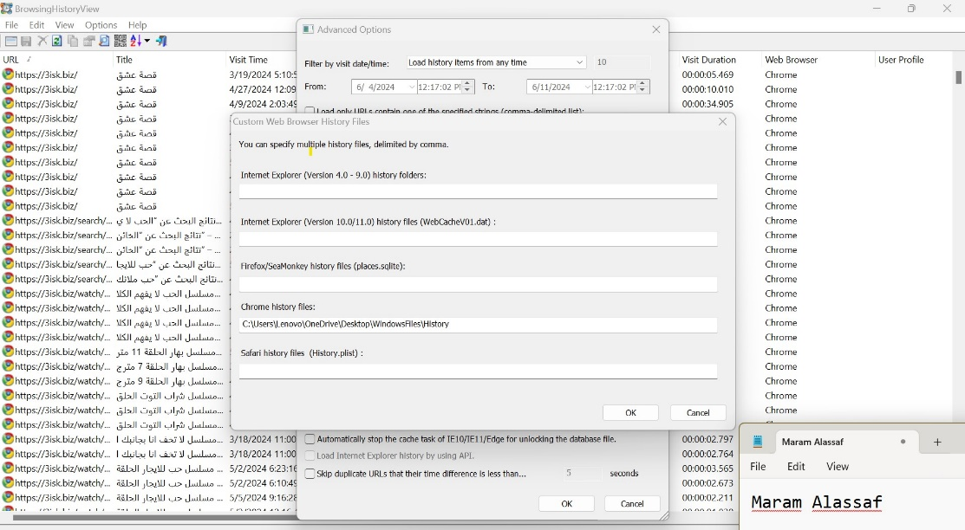I uploaded the History file from Google Chrome to search Chrome’s history:

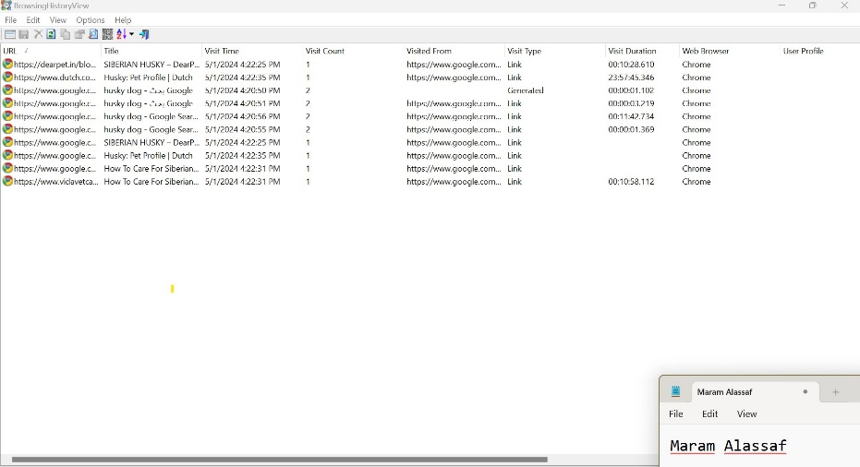Now I was able to view the Chrome’s history

As you can see I did not find anything useful most of the history files were about dogs.

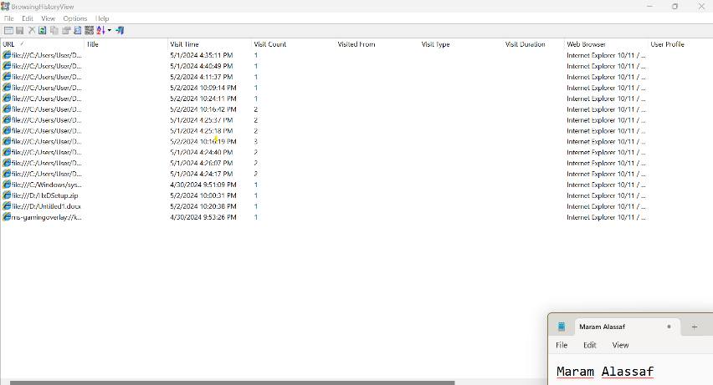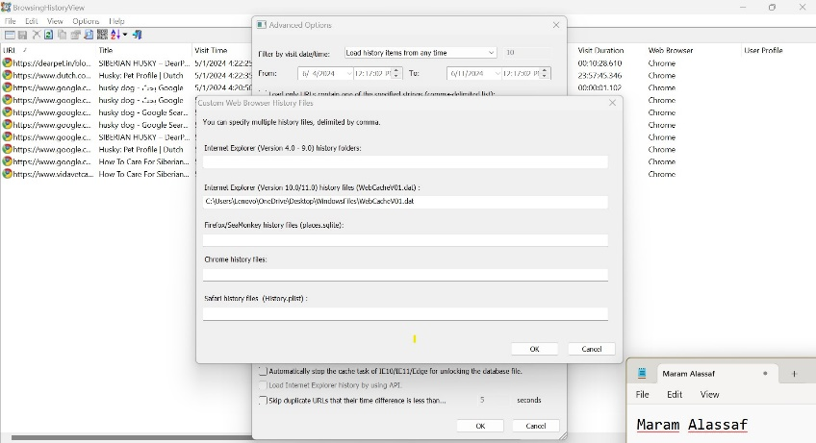Moving to the internet explorer History, first I exported the file then I opened it using the browsing history tool:

There are multiple downloaded files from internet explorer which I found suspicious, and these files were jfif files.

1. Jumplist files using (JumpListExplorer):

I exported the automated and custom files using FTK Imager, and then I opened these files using the jumplistexplorar:

* 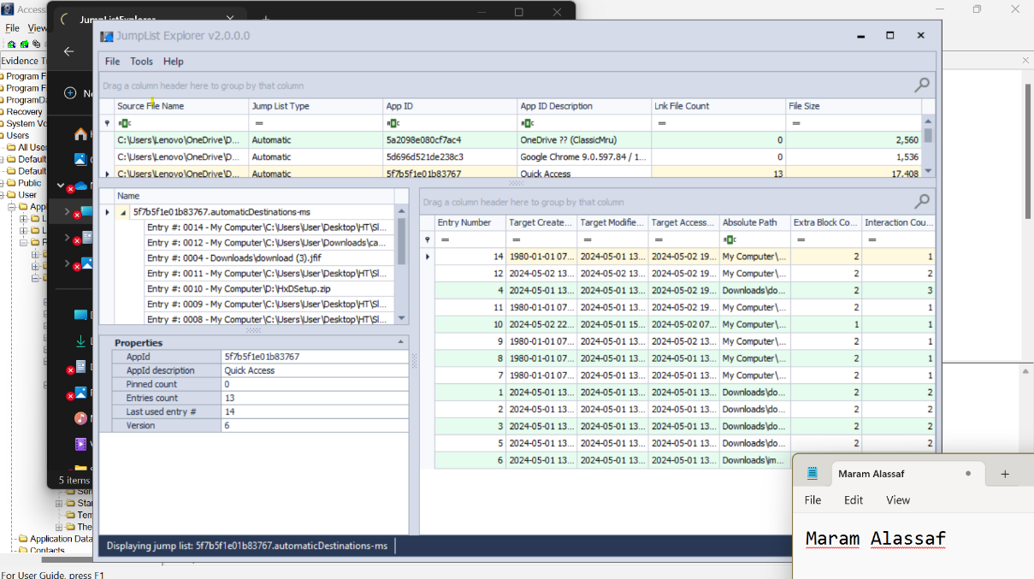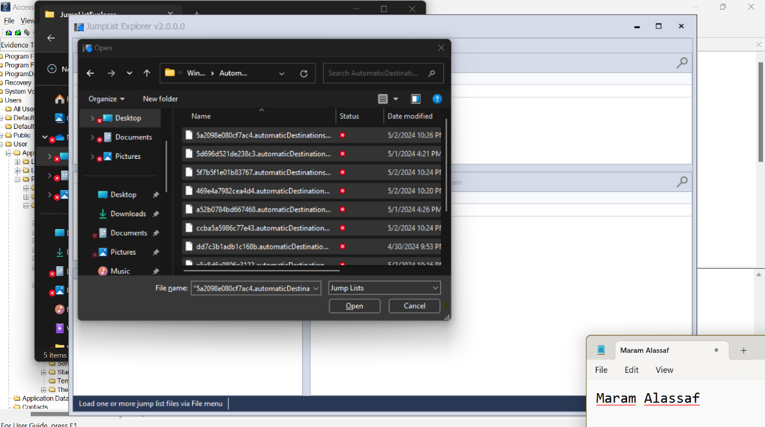Opening the **Automatic** Files:
* 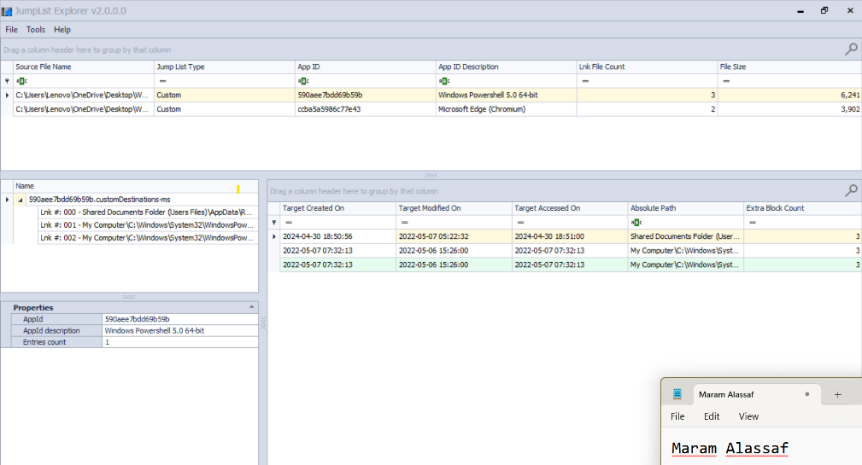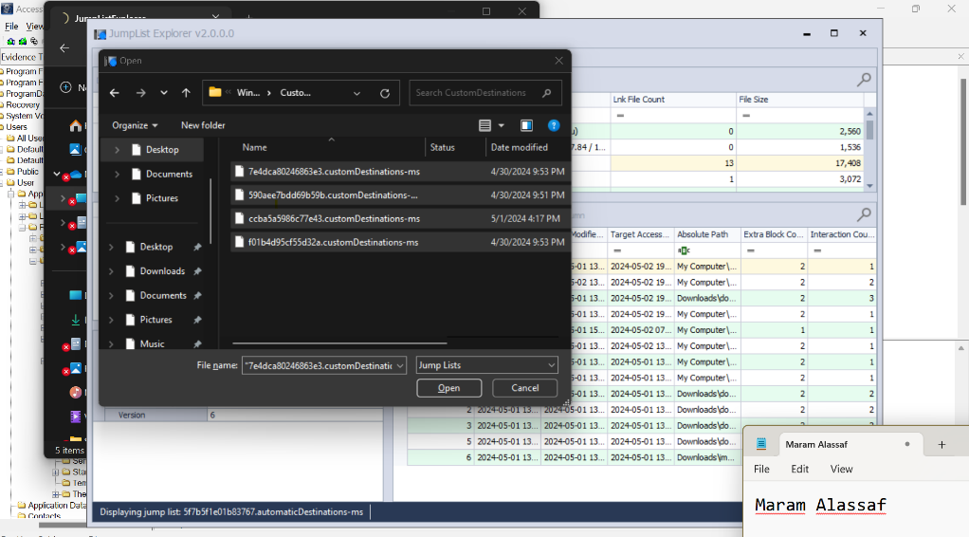Opening the Custom Files:

1. Thumbnail files using (Thumbcache_Viewer):

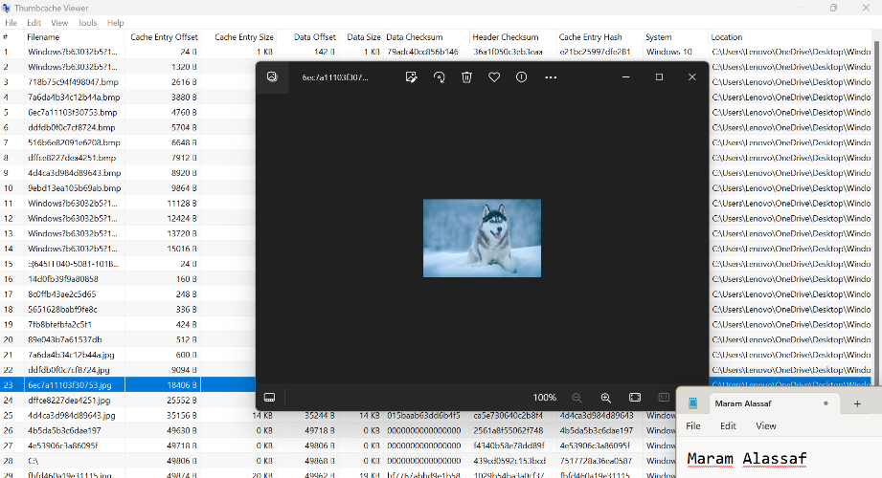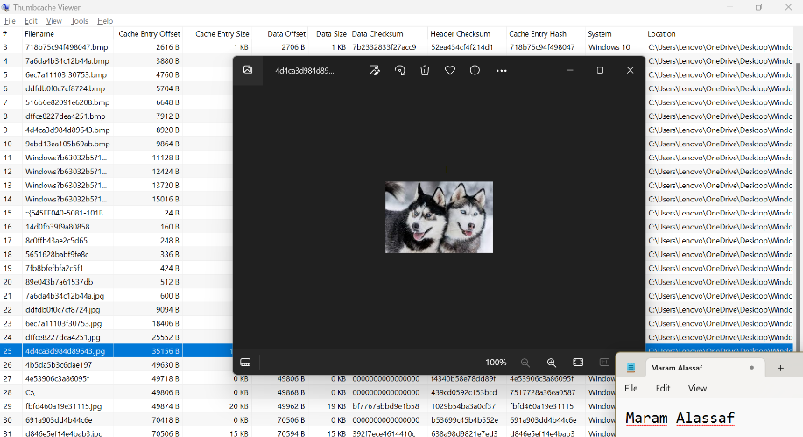I chose random thumbnail files and saved them to see the content of them. most of them were dog pictures, but the cage pictures were suspicious so I kept this in mind:

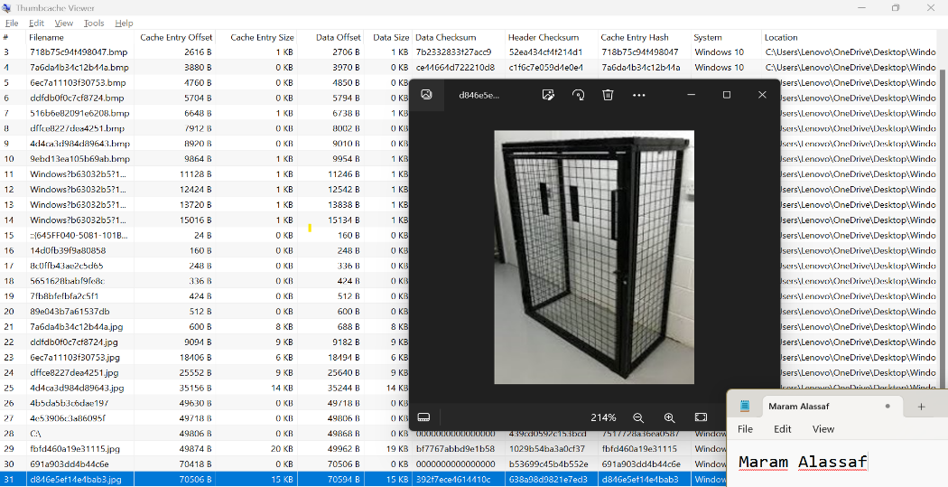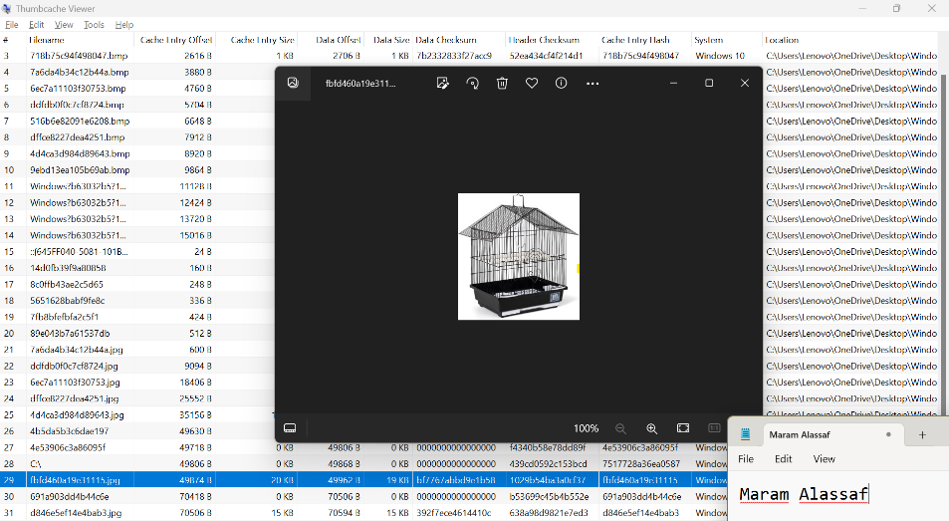

I started connecting the points that these pictures were uploaded from Internet Explorer.

1. Recycle Bin Using (RBCmd):

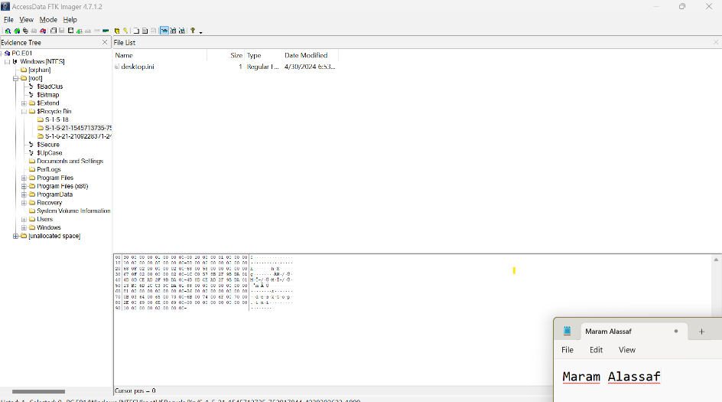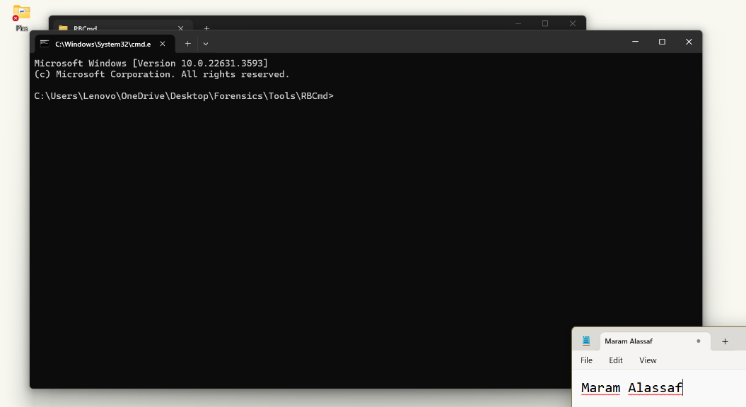I wanted to check the recycle bin in case the suspect deleted a file but forgot to delete it from the recycle bin.

But I found out using the FTK Imager that all the recycle bin files were deleted. And RB was empty.

1. Link Files Using (LECmd):

I wanted to check the link files as evidence that the item was previously present and subsequently deleted:

So when I opened the Link files path on the FTK imager I found many link files but there is one file was odd to me which was the cage.png.lnk file

As you can see the file was created on 02-05-2024, so I kept that in mind.

1. Manual searching using the FTK Imager:

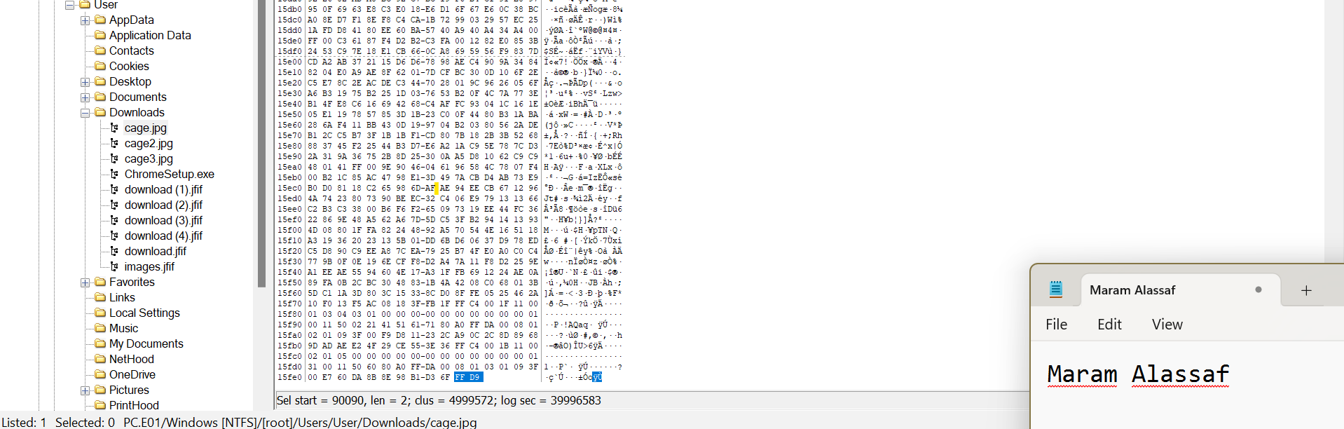When I searched the Internet Explorer history I found that many files were downloaded as jfif files, then, when using the Jumplist tool I was able to access these pictures and I found a cage file so I wanted to manually access the download using the FTK Imager, I found the cage picture, I opened the hexadecimal value for this file:

To check the trailer value for the jfif file, I used a website:

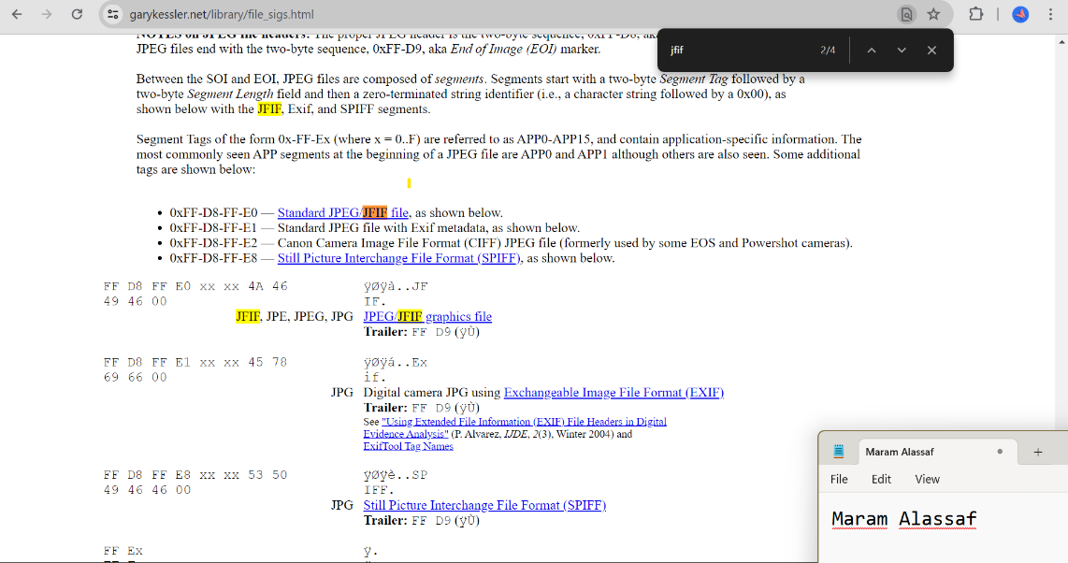Which was FF D9, and the first picture trailer was correct, so I moved to the second jfif file.

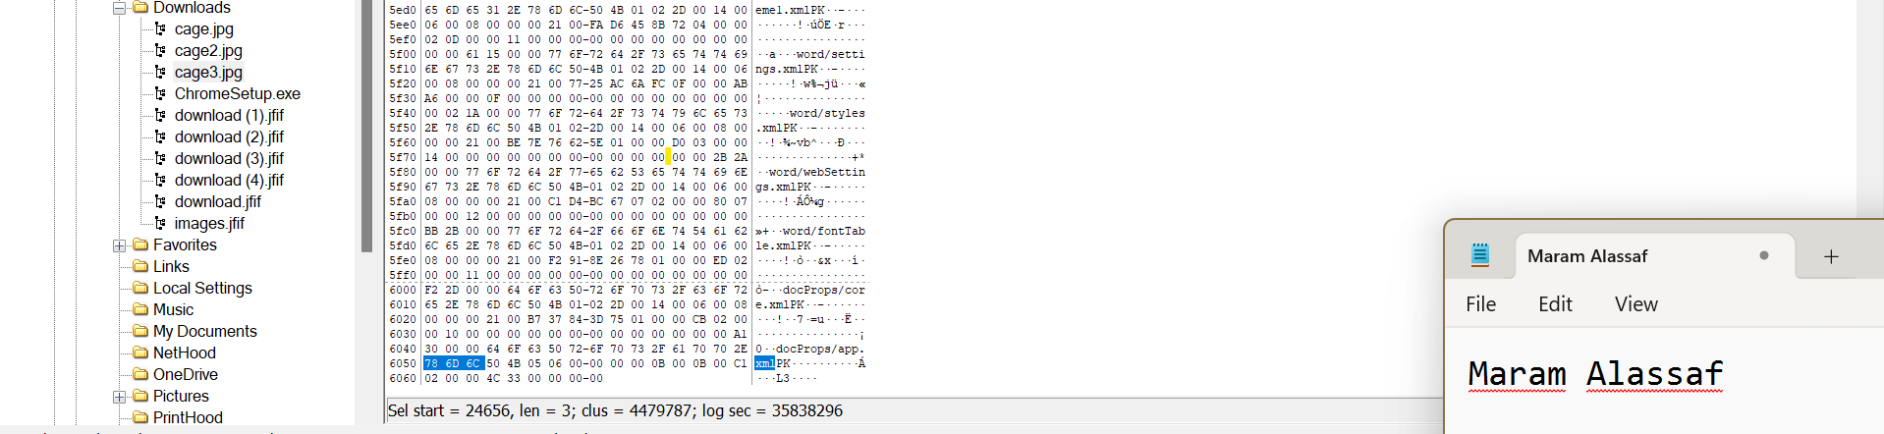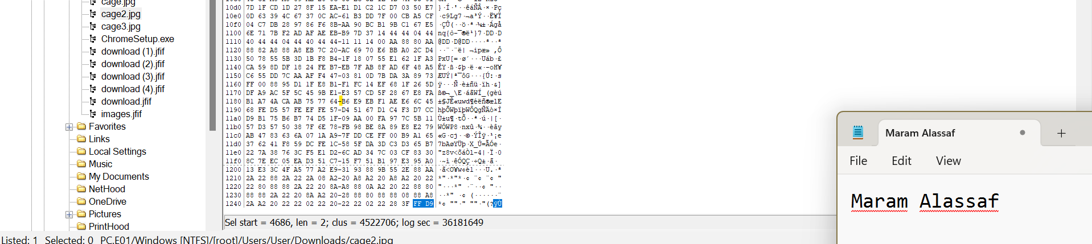As you can see here in the second jfif file the trailer value was FF D9, which is correct, now moving to the third jfif file (Cage 3):

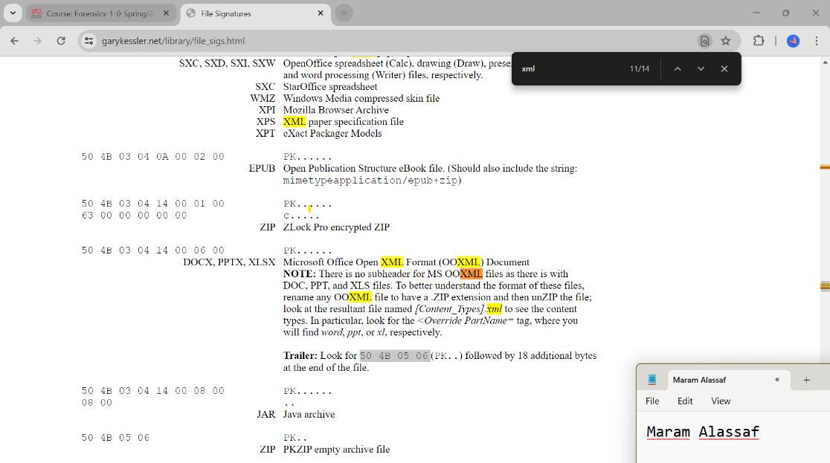This file was a XML file, while this file should be ending with FF D9 instead it ended with 50 4B 05 06 From the trailer of this file and the written xml on the right I was sure of that:

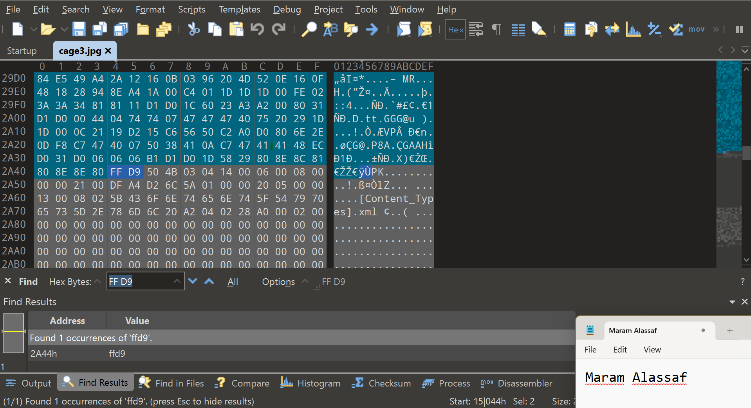I exported the cage 3 file and opened it using the 010 editor, and I searched for the trailer of the jfif file, it was in the middle of the hexadecimal file. I knew that the XML file was hidden inside the jfif file.

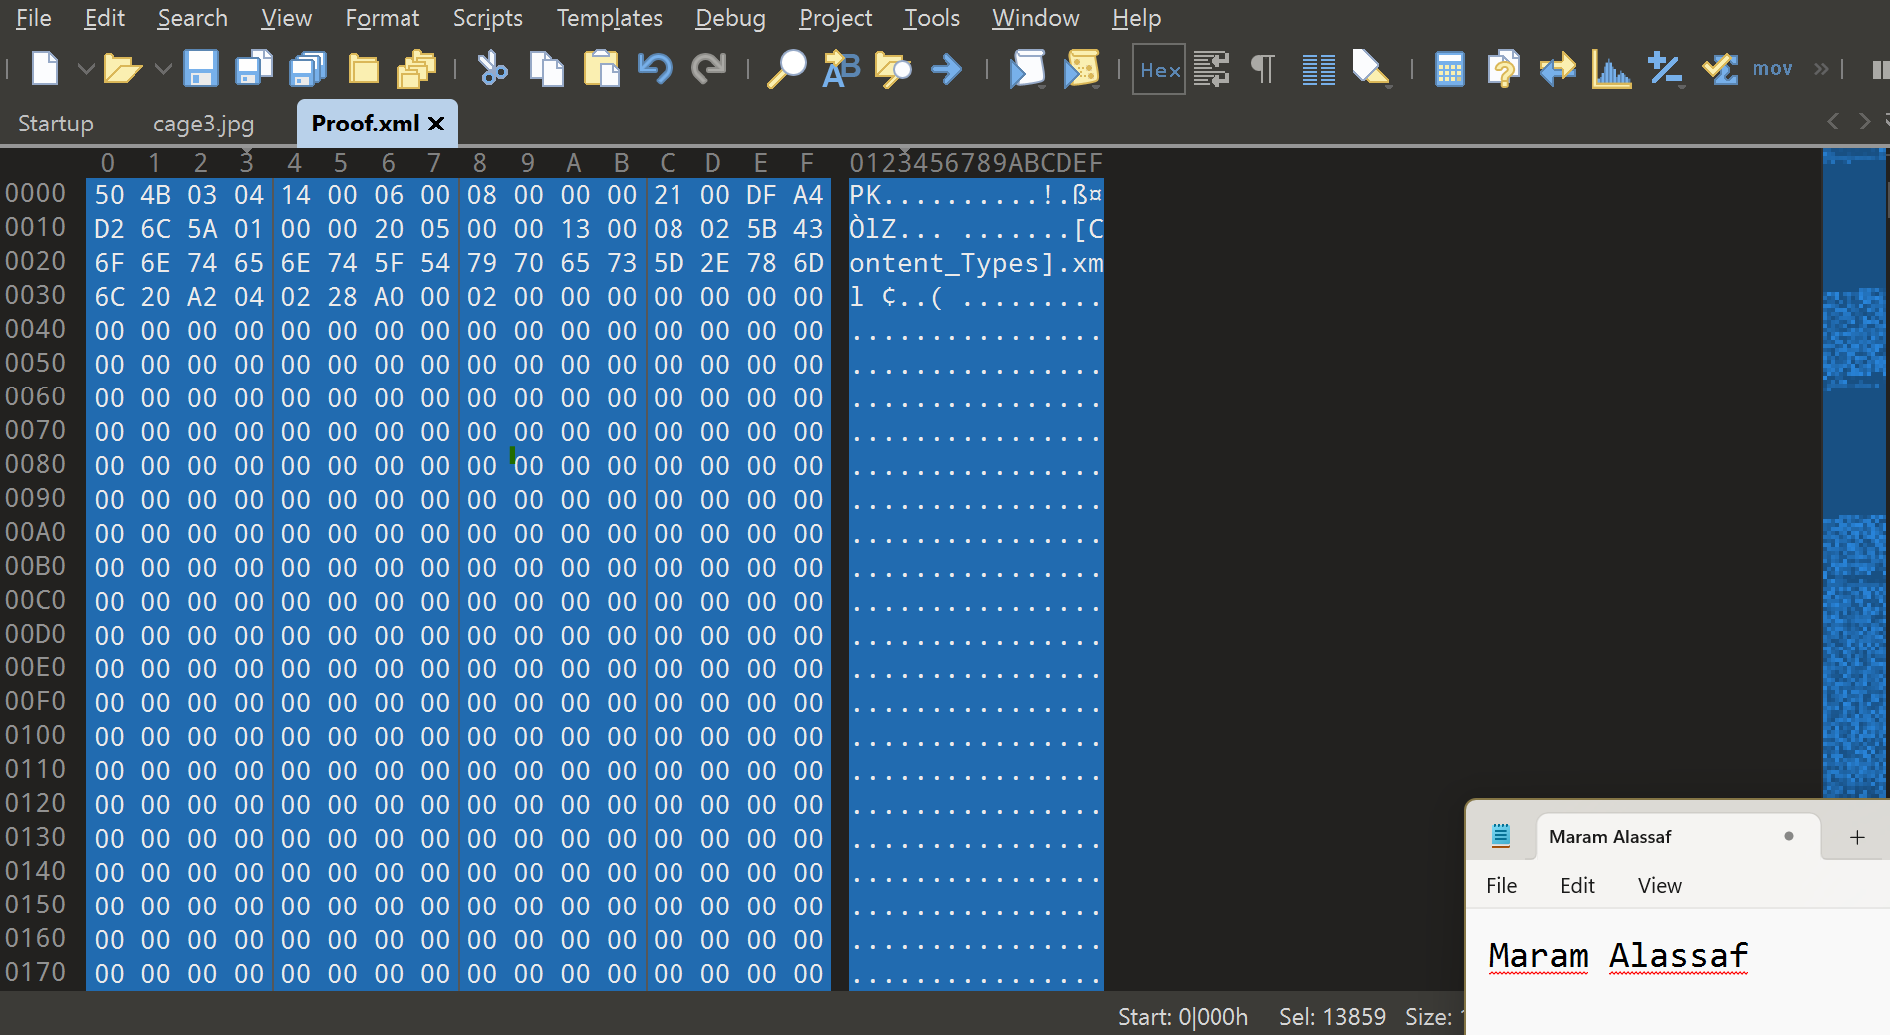Then I copied the the file after the FFD9 till the end and opened a new hex file pasted it there, saved it and tried to open it, unfortunately an error message popped and I was not able to open the file

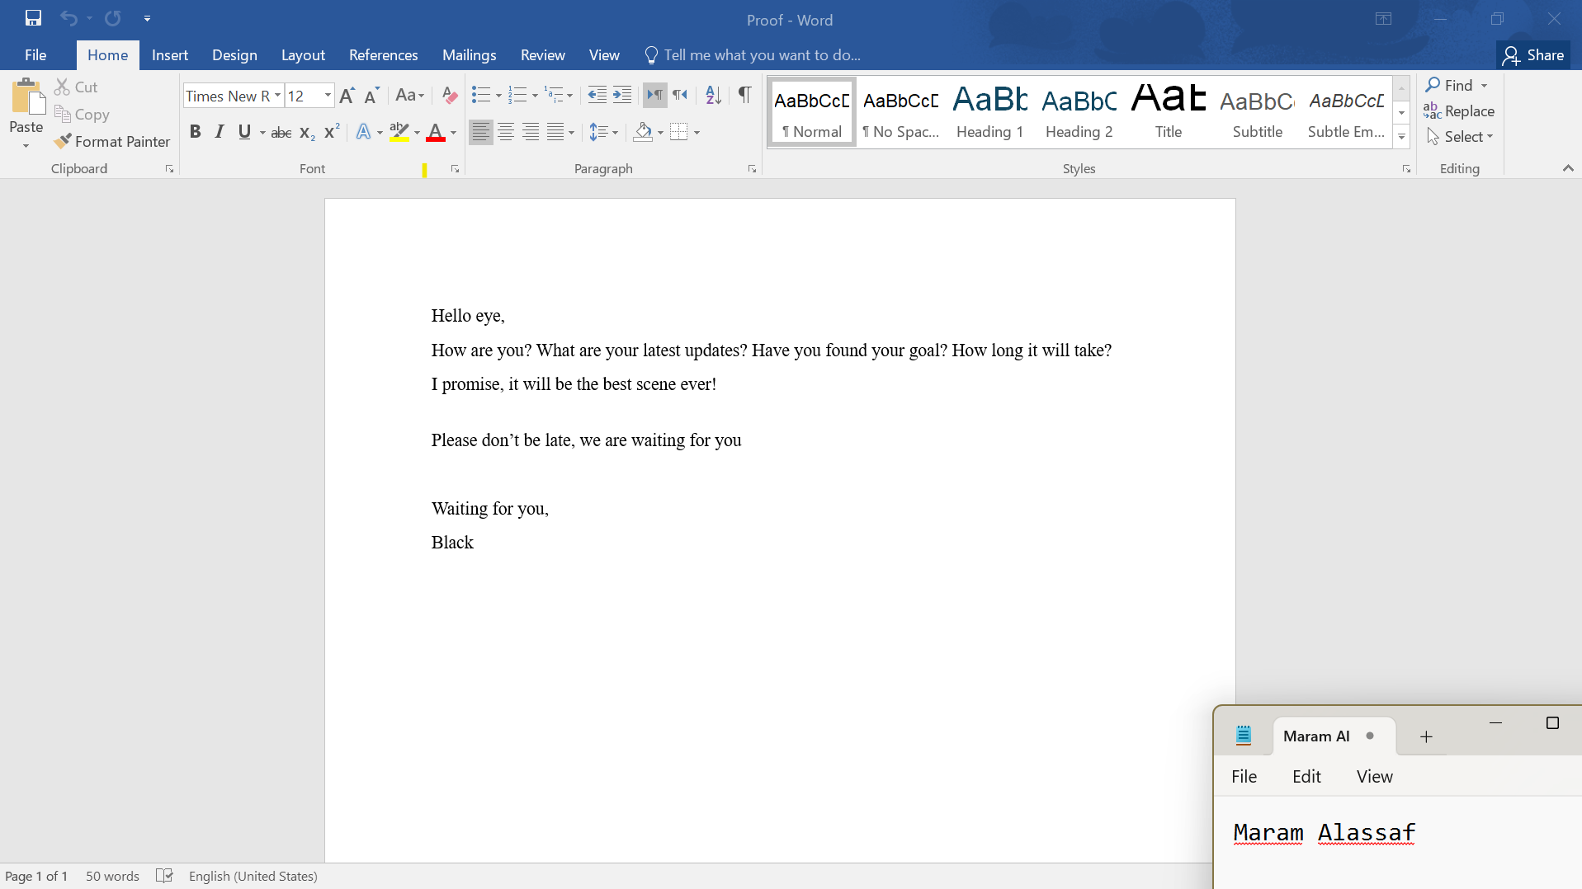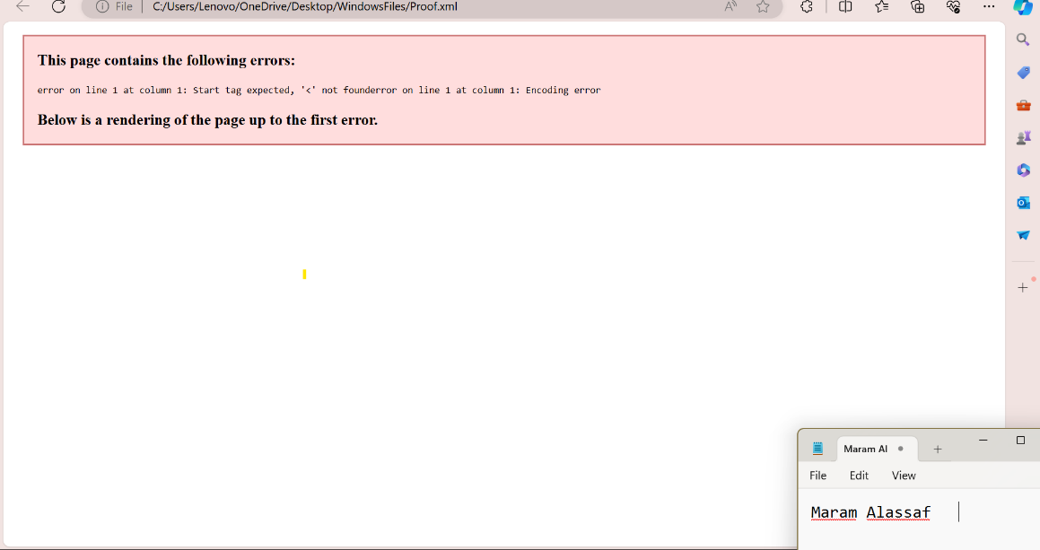So I opened it using Microsoft Word:

It was obvious that not all data was showing, so I selected the words and then changed the font color to black:

# Conclusion

To conclude after doing the analysis and finding the time and location of the next crime, I used multiple tools to help me to find this information.

Firstly, I started by editing the missing part in the USB which was the VBR, and put it in the right place. Then went to the PC device to search for any hints and information that could lead us to the time and location, I used the browser history, link files, JumpList, and Recycle bin, and then I moved to the manual search. The widows' artifacts did not provide any evidence to me, but they gave me hints about how to reach the evidence, lastly, by using manual searching I was able to find the time and location hidden in another file. Which was on Tuesday 11-6-2024 at 12 PM in KHBP.

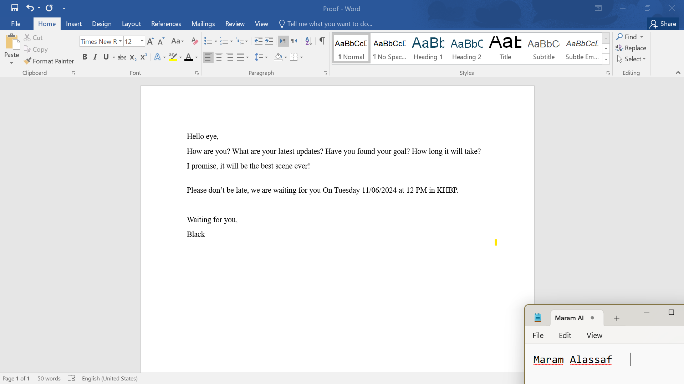**Here is the time and location of the next crime.**

# Exhibits

Similar to the appendices. It contains COC. Extracted files details (including their hash values). Also, it contains the external reports generated by the used tools in the investigation.

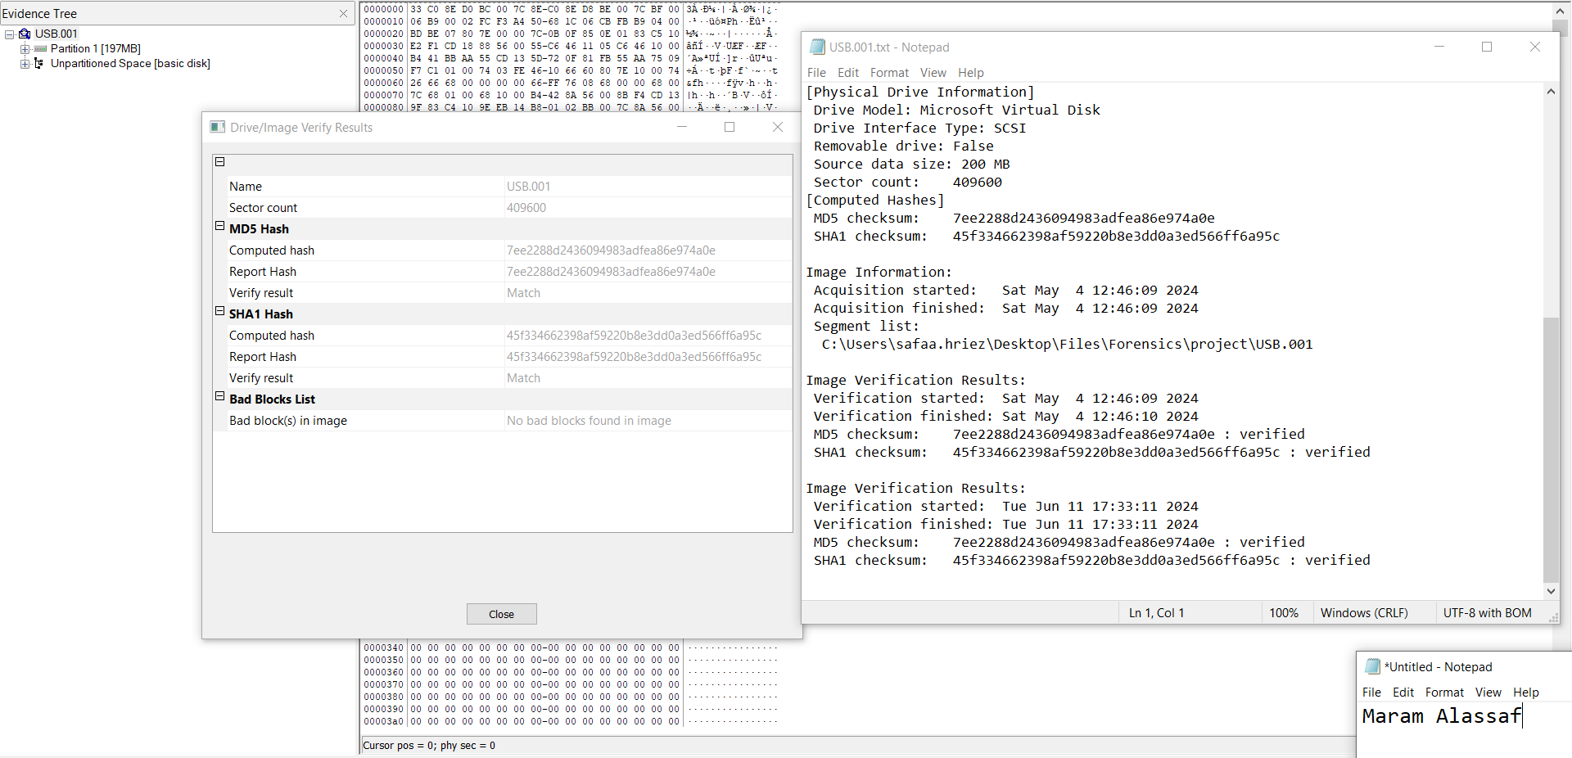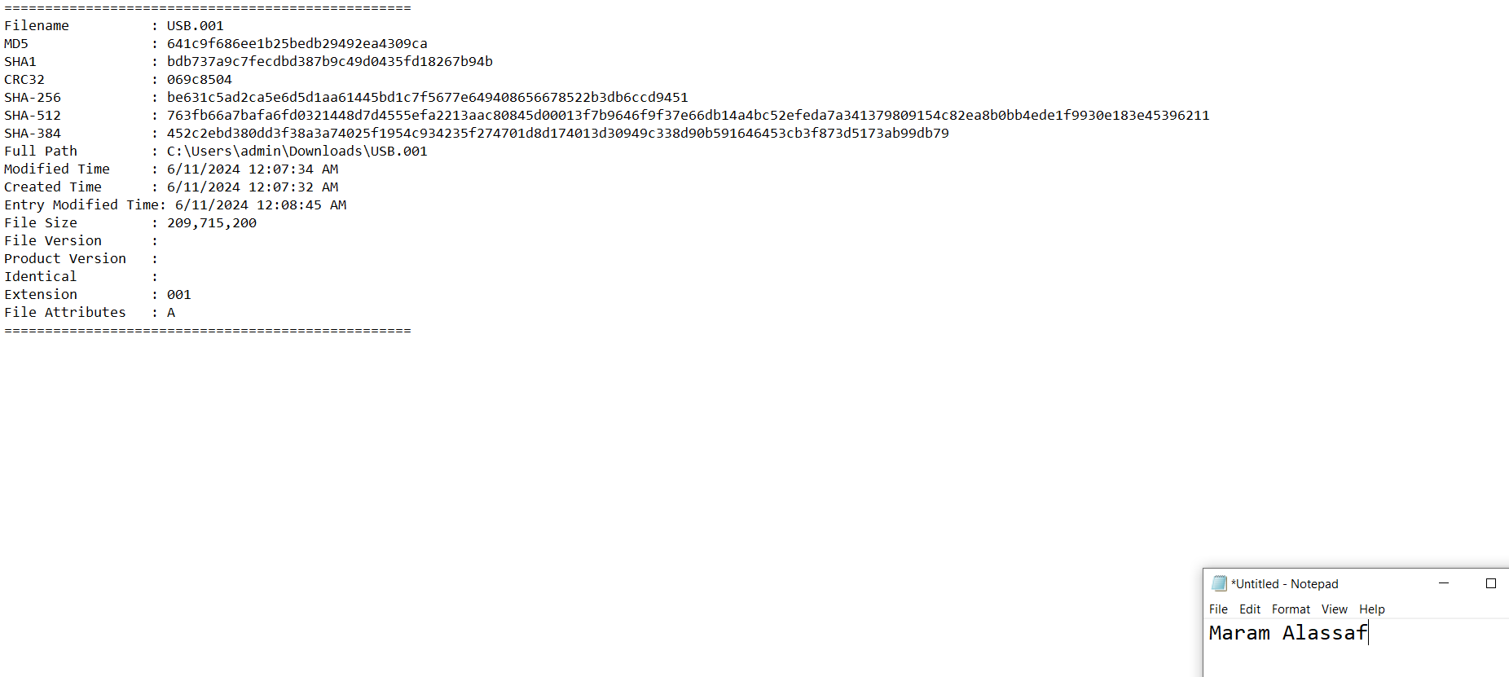The Hash Value for the USB after editing it:

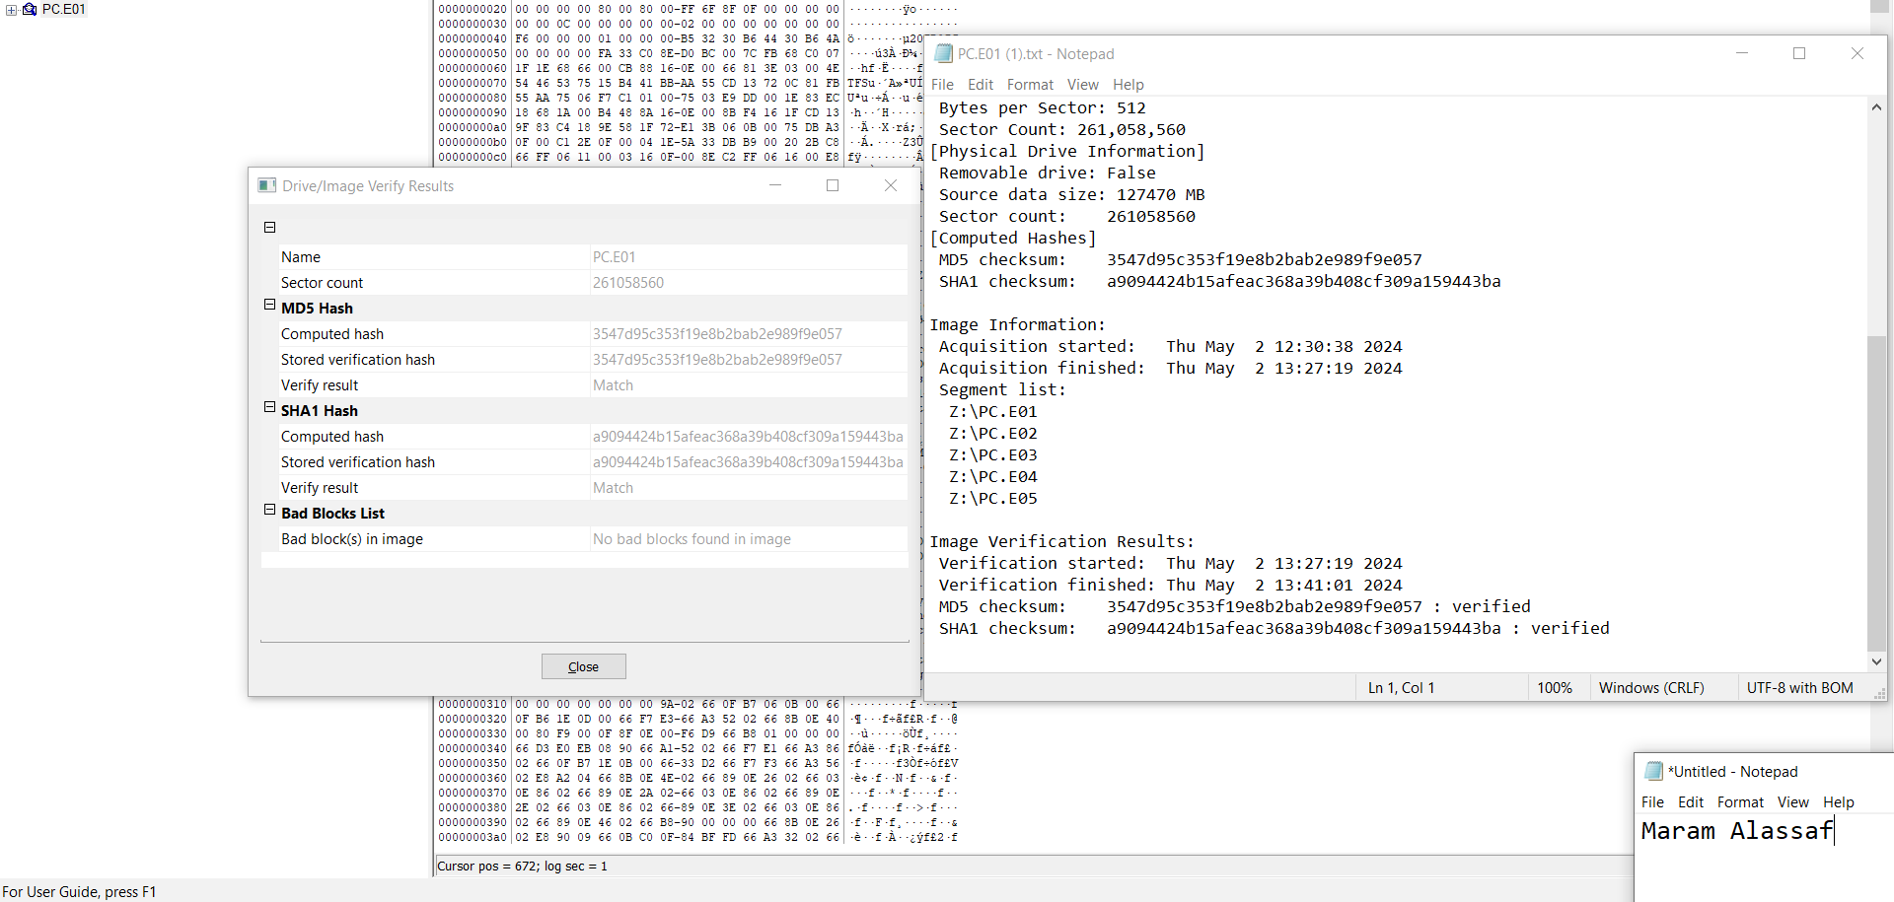

Chain of Custody (COC):

* USB drive:

|  |  |  |  |  |  |  |
| --- | --- | --- | --- | --- | --- | --- |
| **Al-Assaf Investigation Organization**  This form is to be used only for one piece of evidence.  Fill out a sperate form for each piece of evidence | | | | | | |
| Case No: | | 751515 | | Unit Number: | MA_25 | |
| Investigator: | | Maram Alassaf | | | | |
| Number of Case: | | 5 | | | | |
| Location where evidence was obtained: | | The evidence, was obtained at the suspect's residence located at 123 BlackEagle Street, Amman. | | | | |
| Item #ID | Description of evidence: | | Vendor Name: | | Model No/Serial No: | |
| 1 | A damaged and edited USB drive | | NA | | NA | |
| Evidence Recovered by: | | Maram Alassaf | | | Date & Time: | June 11th  3:05pm |
| Evidence Placed in Locker: | | The USB drive was placed in Evidence Locker #25C at the Metropolitan Police Forensic Laboratory. | | | Date & Time: | June 11th  3:05pm |
| Evidence Processed By | | | Disposition of Evidence | | | Date/Time |
| Maram Alassaf | | | Preserved for further analysis. | | | June 11th  3:05pm |
|  | | |  | | |  |
|  | | |  | | |  |
|  | | |  | | |  |
|  | | |  | | |  |
|  | | |  | | |  |
|  | | |  | | |  |
|  | | |  | | |  |
|  | | |  | | |  |
|  | | |  | | |  |
|  | | | | | | Page_1_of_1_ |

* PC device

|  |  |  |  |  |  |  |
| --- | --- | --- | --- | --- | --- | --- |
| **Al-Assaf Investigation Organization**  This form is to be used only for one piece of evidence.  Fill out a sperate form for each piece of evidence | | | | | | |
| Case No: | | 751515 | | Unit Number: | MA_25 | |
| Investigator: | | Maram Alassaf | | | | |
| Number of Case: | | 5 | | | | |
| Location where evidence was obtained: | | The evidence, was obtained at the suspect's residence located at 123 BlackEagle Street, Amman. | | | | |
| Item #ID | Description of evidence: | | Vendor Name: | | Model No/Serial No: | |
| 1 | A Dell OptiPlex 7080 desktop computer containing critical evidence such as emails, documents, browser history, and encrypted data, revealing the suspect's involvement in BlackEagle's operations. | | NA | | NA | |
| Evidence Recovered by: | | Maram Alassaf | | | Date & Time: | June 11th  3:10pm |
| Evidence Placed in Locker: | | The PC device drive was placed in Evidence Locker #47B at the Metropolitan Police Forensic Laboratory. | | | Date & Time: | June 11th  3:10pm |
| Evidence Processed By | | | Disposition of Evidence | | | Date/Time |
| Maram Alassaf | | | Preserved for further analysis. | | | June 11th  3:10pm |
|  | | |  | | |  |
|  | | |  | | |  |
|  | | |  | | |  |
|  | | |  | | |  |
|  | | |  | | |  |
|  | | |  | | |  |
|  | | |  | | |  |
|  | | |  | | |  |
|  | | |  | | |  |
|  | | | | | | Page_1_of_1_ |